DigiRAMP strategy 2015

A Content Delivery Network for Music

Integrate Rights and Media with Administration

Cut costs by Automation and Pay stakeholders in real-time

Promote Artists and Content directly to consumers

Build an audience with social features



Everyone get opportunities and tools to fulfill their own needs to the benefit of all people all over the world.

Everyone should own their life

Table of content

DigiRAMP an Ecosystem for music 4

Users on DigiRAMP 5

Listeners and fans 5

Influencers 5

Aspirational artists / Amateurs 5

Professionals 6

Brands and Advertisers 6

Content Providers 7

Aggregators 7

Indie labels 7

Professional creators 7

Aspirational artists and amateurs 7

Bands 7

Music buyers 8

Consumers 8

Music supervisors 8

Resellers / Curators 8

Legal frameworks 9

Mechanical usage 9

AV License 10

Other usage 10

Breaking down barriers 11

Example: Sync Licensing 12

Example: Sync Licensing on DigiRAMP 13

Delivery Networks 14

Scenario 14

Marked size and trends 15

Publishing 15

Production and Creation 16

Distribution 17

Live Performance 18

Streaming 19

Companies and competitors 21

Indie record labels 21

Majors 21

Streaming services 23

Social networks 25

Aggregators 26

Recent Music Startups 27

Gigmor 27

Linkfire 28

Potential revenue streams for DigiRAMP 29

Current Business model 29

Branding 30

Evaluation of a user on a social network 31

Clue 31

Instagram 31

Skype 31

Development team 32

Server provisioning / IT Infrastructure Chef 32

Code documentation. Automated test. Patents 32

Research and Development 32

UX / Interaction Designer 32

JavaScript wizards 32

ROR Workhorse 33

Database captain 33

Minister of Integration 33

Widgets (external) 34

OS X (external) 34

iOS (external) 34

Windows (external) 34

Android mobile application (external) 34

Plug-in’s (external) 34

Team over view / number of positions 35

# DigiRAMP an Ecosystem for music

DigiRAMP is a music ecosystem that makes it easy and efficient to Interact Conduct business and grows an audience. Everyone get responsibility and tools to fulfill their own needs to the benefit of al parties.

There are people who create music and people that listen to it. In between are the rest of the ecosystem taking care of distribution, rights and payments, there are also people finding music and recommend it for different usage.

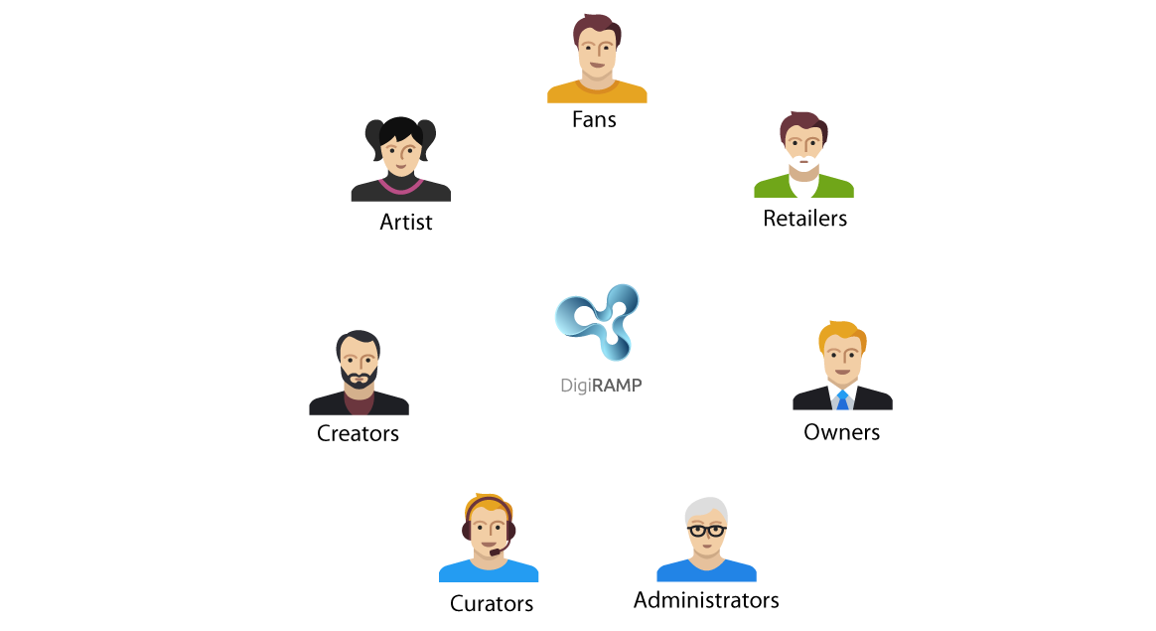

Some of the players in the music ecosystem. There are more.

# Users on DigiRAMP

Users are the most valuable asset on DigiRAMP, here is some general assumptions we all can agree on

* Users sign up one by one
* Are segmented in different kinds
* Have different preferences and needs.

## Listeners and fans

This group is the largest. It’s also the bottom of the food chain and everyone wants access to this group.

They join DigiRAMP because they get.

* Easy access to free music.
* Great content curated in playlists.
* Stories behind the music.
* Cool graphics and videos
* Tools to share what they like and do
* Access to engage with peers artists

## Influencers

DJ’s. Pretty girls. Artists. YouTubers. Comedians. Explainers. They are today’s online trendsetters.

They join DigiRAMP because they get

* A media to communicate true
* Ways to monetize on their followers
* Metrics and data on their followers

## Aspirational artists / Amateurs

Individual. Bands. DJ’s, Songwriters. Composers. Producers. Artists.

This group represents many of the different kind of parties in the music universe.

This group is the second largest group of users.

They join DigiRAMP because they get.

* Opportunities
* A way to find people to collaborate with
* A merchant system
* Legal documentation and protection
* Exposure
* Recognition
* Promotional tools
* They can participate in contests

## Professionals

Individual. Bands. DJ’s, Songwriters. Composers. Producers. Artists. Indie Labels. Curators. Music Supervisors. This group represents most of the different kind of users

They join DigiRAMP because they get

* An easy. Efficient and cost effective way to conduct business
* A way to own their customers and clients and monetize directly on them
* Promotional tools
* Metrics

## Brands and Advertisers

Many artists and bands build relations

* Artists promote instruments
* Artists promote closing
* Brands sponsor events
* Brands sponsor competitions

# Content Providers

It’s easier to get content than users. Content can be provided in bulk.

Content also is the ultimate driver and what brings everyone together on DigiRAMP.

## Aggregators

* Collect and organize music
* Delivers to online shops
* Have huge catalogs from ten of thousands to millions of songs.
* Want cleared music easy to ingest

## Indie labels

* Have songs in the range from hundred to tens of thousands organized in catalogs
* Have knowledge of the industry
* Are missing delivery network

## Professional creators

* Have a lifetime of produced music. Up to 200 songs.
* Many contributors on the productions
* Overall high quality on the music
* Uses real musicians
* Have registered with PRO’s
* Have some knowledge of the industry
* Are self published

## Aspirational artists and amateurs

* There are many of them
* Have 10 to 20 songs
* They are produced in a project studio
* The quality of the music are mostly low
* They wants to collaborate
* Are seeking recognition more than everything
* Have limited knowledge of the industry
* Have no label or publisher
* Are willing to spend money on tools subscriptions and promotion

## Bands

* Have 10 to 20 songs
* Are produced in a project studio
* Have few contributors on the songs
* The quality of the music are mostly low
* Are seeking recognition more than everything
* Have limited knowledge of the industry
* Have fans in the thousands to the hundred of thousands
* Have poor legal documentation
* Spends money on promotion

# Music buyers

Consumers are not the only customers for users that own or control content on DigiRAMP.

## Consumers

Consumers buy an end user license for personal usage of a song.

They use DigiRAMP because they:

* Wants niche music
* Want curated playlists
* Want a sexy interface
* Want metadata and stories
* Want images together with the music
* Want to support the artist and creators directly

## Music supervisors

Music supervisor’s works typical on the behalf of an AV production

They use DigiRAMP because they:

* Want 200% cleared music
* Want legal documentation
* Want a fast work flow and interaction with interested parties
* Want a delivery system for distribution to their clients

## Resellers / Curators

They use DigiRAMP because they:

* Want legal documentation
* Want metadata
* Want cover arts
* Want to cherry pick content from many providers
* Want to deliver sponsored content

# Legal frameworks

The music industry is regulated by law and requires a set of agreements to be signed by the interested parties.

## Mechanical usage

DigiRAMP provides all features required to make a mechanical sale to an end user

* Legal templates,
* Digital Signatures.
* Automated real time micro payments
* A personal embeddable shop

By doing so all users have the opportunity to sell content with rights cleared. Legal documentation by the book and without violating any rights

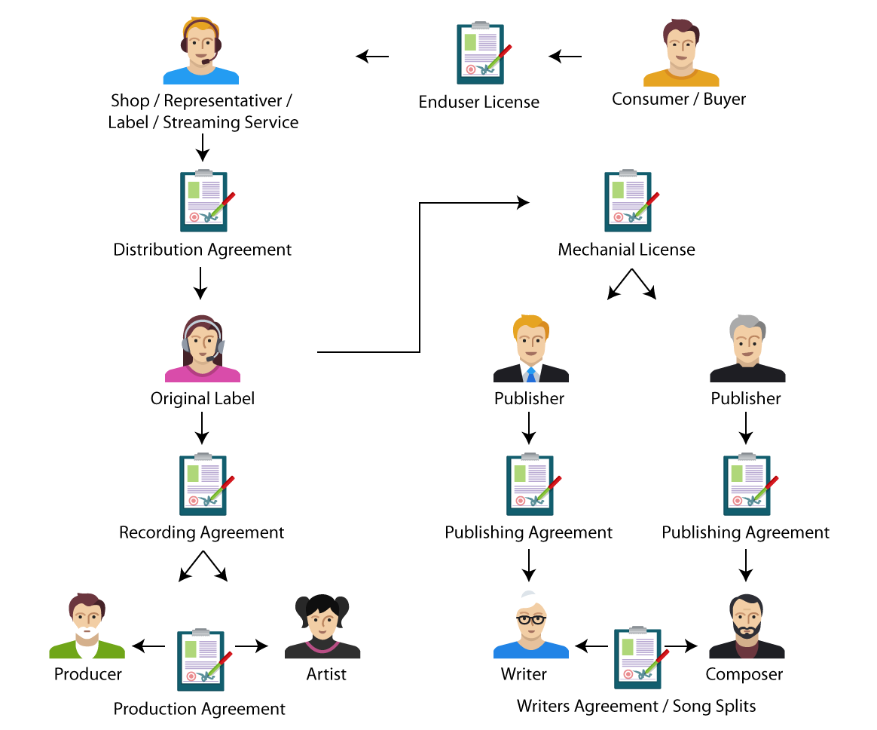

## AV License

DigiRAMP provides all features required to make a mechanical license for an AV production

* Legal templates,
* Digital Signatures.
* Automated real time micro payments

By doing so all users have the opportunity to sell content with rights cleared. Legal documentation by the book and without violating any rights

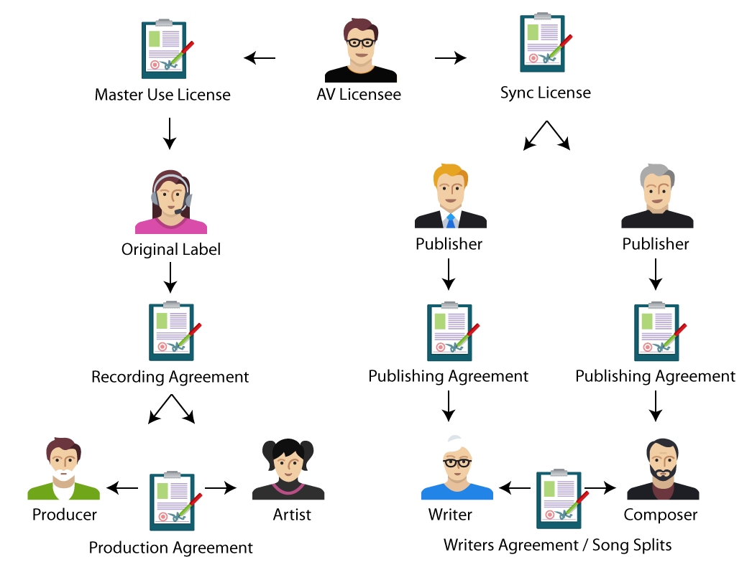

## Other usage

The legal framework on DigiRAMP is tailored to the music business but is also flexible enough so it can be used for other purposes

* Services
* Administration deals
* Revenue streams

# Breaking down barriers

Traditionally the music industry is segmented between different sectors

* Sales to end consumers
* Management of rights
* Collection of royalties
* Distribution
* Licensing
* Production

Hence the information is scattered out on different companies. Stored in different formats in different databases. Covered by different laws and regulations.

* There is a limited to no automation.
* The manpower used for administration is out of proportion with the turnover
* It’s unnecessarily complicated to conduct business
* There is close to nothing left to creators
* There is no transparency, so misconducting business is common, also among major players like Youtube. SounCloud. Apple music. PRO’s
* It’s difficult to collect metrics on user behavior

To close this lack of integration DigiRAMP provides a full service, making it easy for all parties to interact in a fair legal and profitable way by reducing the administration cost to close to nothing by using automation.

## Example: Sync Licensing

The traditional interaction between parties is conducted face to face, on phone, and via email. Contracts are printed and signed. Distribution of payments are done true the music supervisor and the owners sending checks or with bank transfers. The time frame is long and up to 50% of the music budget goes the music supervisor

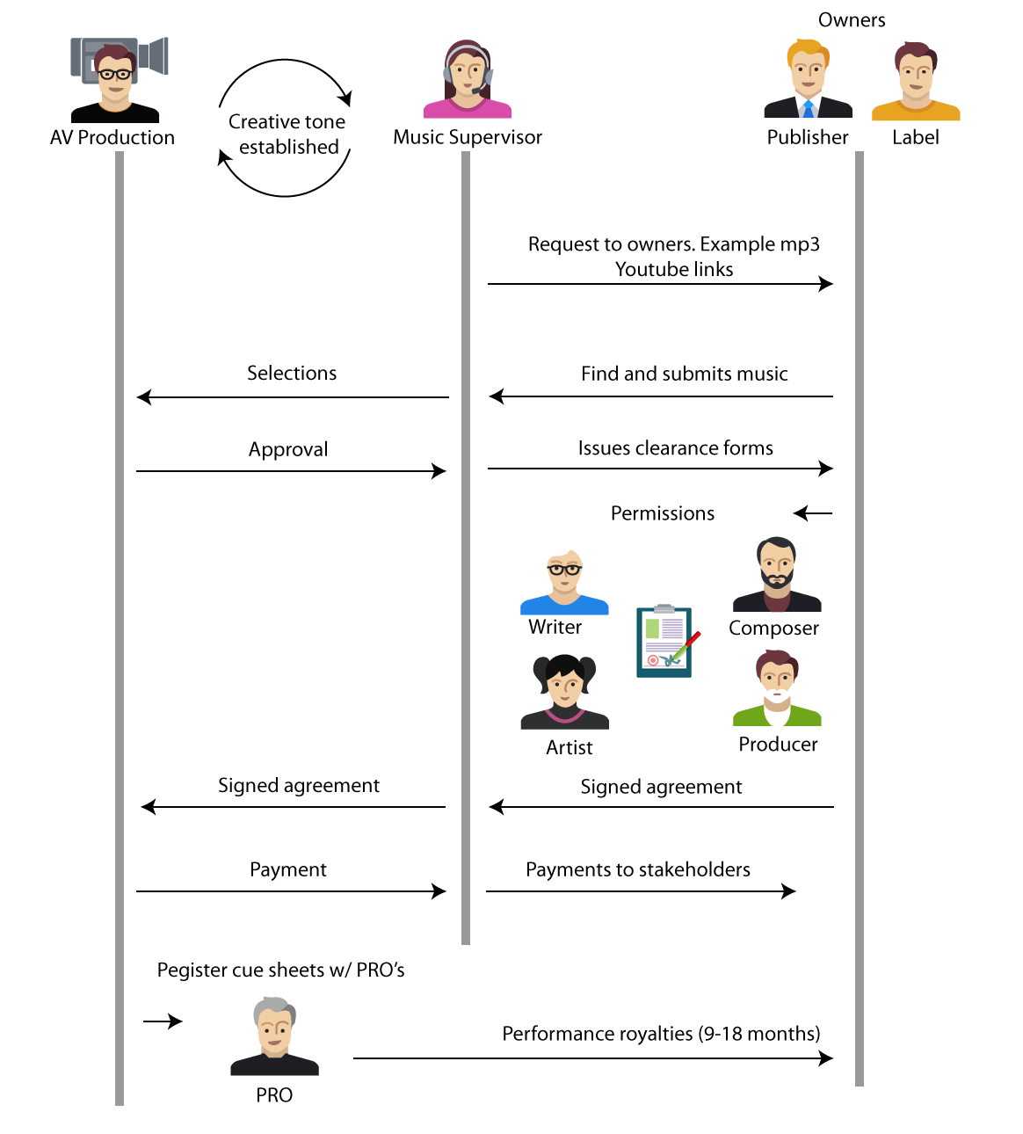

## Example: Sync Licensing on DigiRAMP

Often the work involved in a sync license is not worth the effort for user that owns or controls the content. DigiRAMP automate the process and moves the responsibilities to the parties with an interest in getting the work done.

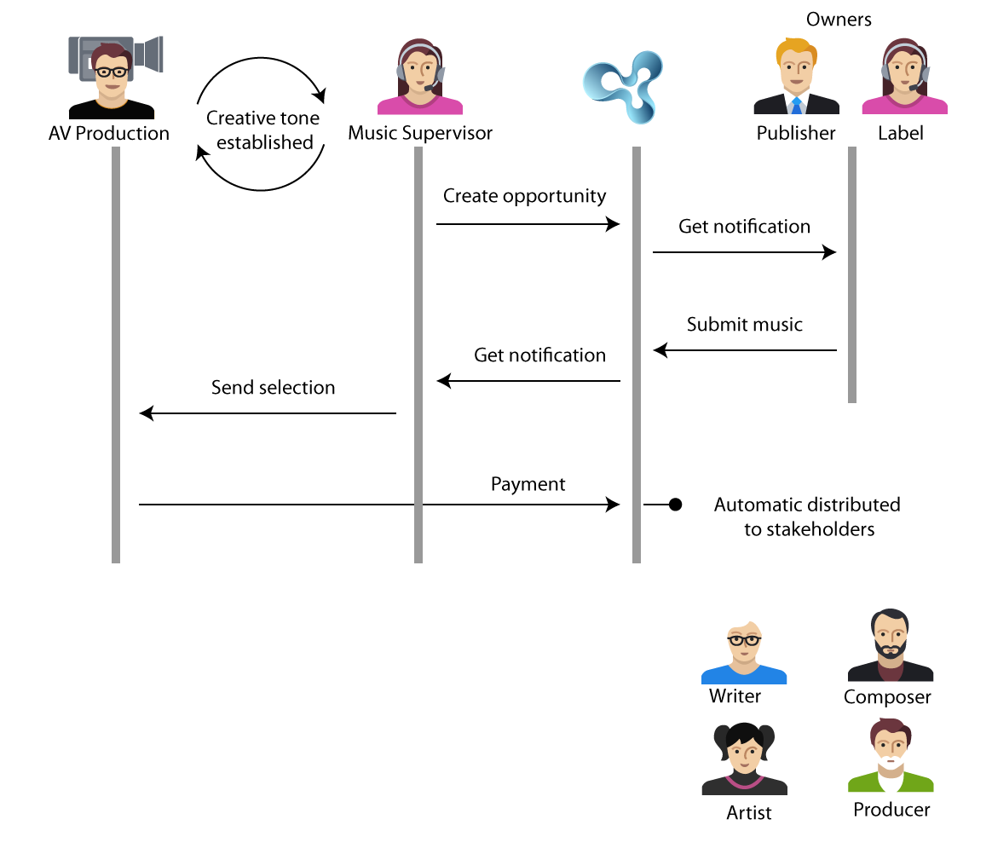

All communication is done from the DigiRAMP web interface; emails and contracts are auto generated, and payments are distributed to all stakeholders in real-time.

# Delivery Networks

Profiling of common used delivery systems for media content

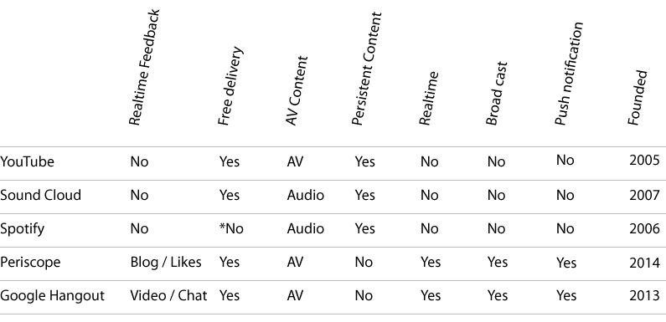

Notice there is a trend towards real-time engagement. I believe there is a great opportunity using DigiRAMP for a promotional tool that delivers a live concert experience to both the artists and the audience.

The closest it Periscope but it has no relation to artists or music and no way to monetize

## Scenario

An artist with a great back catalog and many fans make a channel on DigiRAMP and promote it to friends and fans

Inline purchase

3d models from multiple cellphones

# Marked size and trends

## Publishing

Revenue of music publishing (NAICS 51223) in the United States from 2008 to 2020 (in million U.S. dollars)

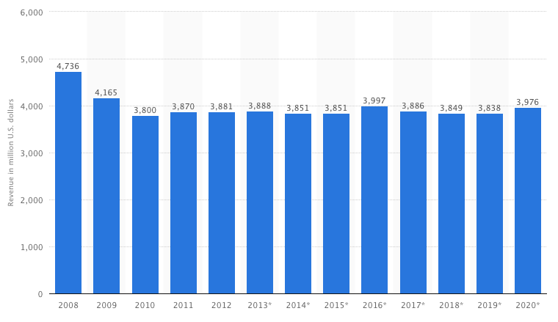

## Production and Creation

* Producers
* Artists
* Writers
* Studios

Revenue of record production 2008 - 2020

Goes from 353 to 653 million

With projected inflation on 2%

653 * (0.98 ^12 ) = 512 mill USD and gives a 45% growth over 12 years or 3.75 a year

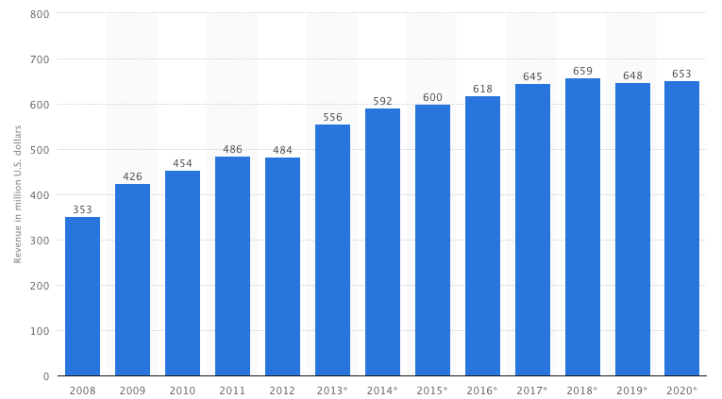

## Distribution

* Physical media
* MP3 downloads
* Streaming services

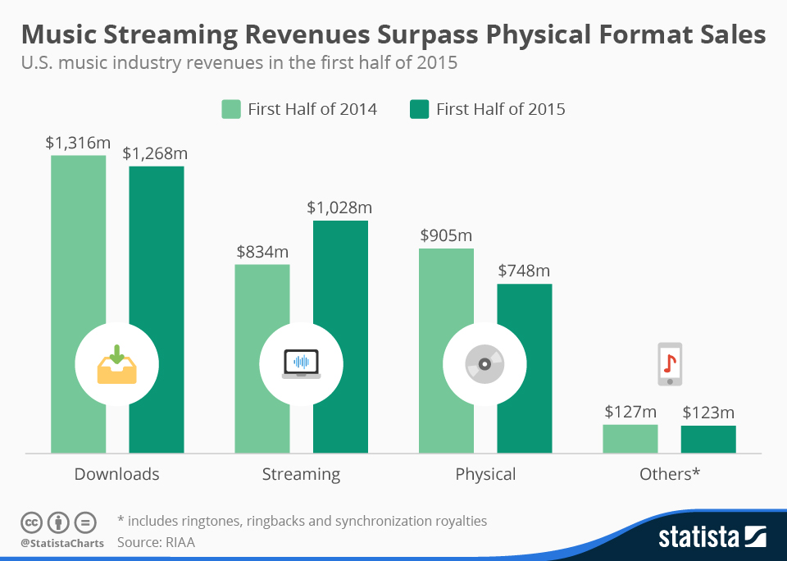

## Live Performance

The global live music industry is surging and is projected to comprise 70% of all music sales in the next 5 years. This is fantastic news for the music industry, artists and musicians, and all of the venues. But if live music is the lifeblood of the industry, why isn’t there a digital marketplace connecting talent buyers and music industry professionals?

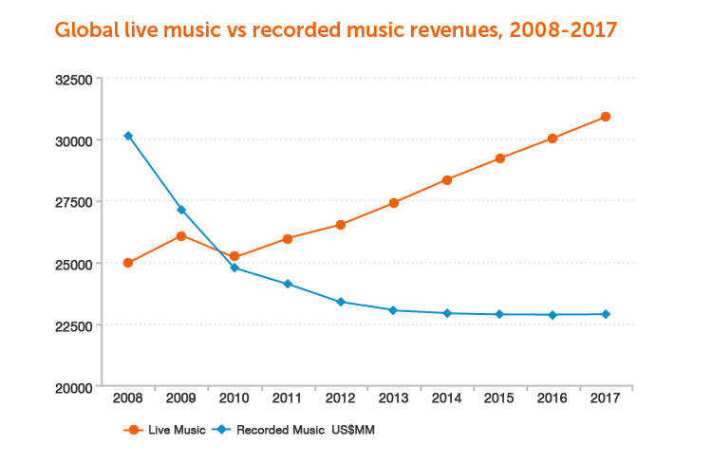

## Streaming

<http://www.ibtimes.com/musicians-songwriters-are-fed-low-royalties-they-are-starting-organize-2160571>

Source International Business Time

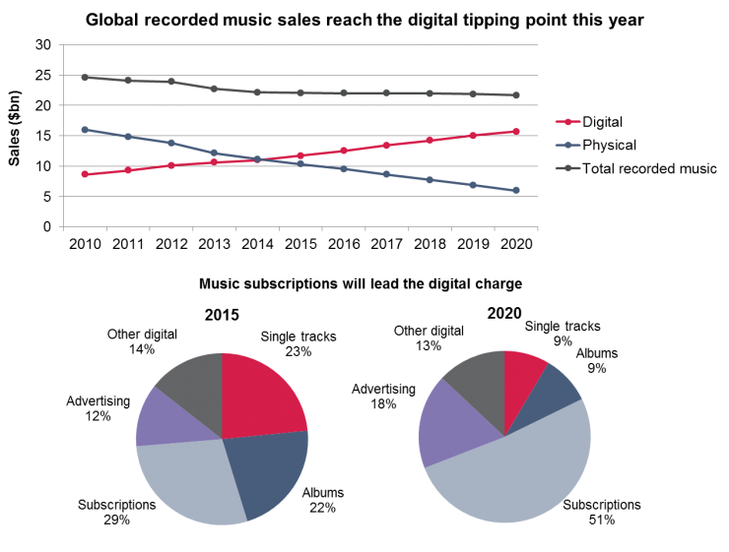

Highlights from article

* The average artist in US make $20,000 a year
* That shift has been traumatic for artists and musicians, who for a whole host of issues -- including a lack of transparency, [administrative problems](http://www.ibtimes.com/music-industry-desperately-needs-global-rights-database-no-one-knows-who-will-pay-it-2129412) and royalty rates negotiated without their input -- have seen their incomes negatively affected by the transition.
* Many prominent legacy artists have begun to raise their voices on issues including a performance royalty for radio and the split of compensation between songwriters and performers on streams

# Companies and competitors

## Indie record labels

Operates without the funding of or outside major record labels

Number Indie labels in US ≈ 6850

Number songs controlled ≈ 2 mil.

*1

A typical indie label is managed by 2-4 persons and has a poor homepage from where it’s possible to buy physical products, merchandise and with links to iTunes and Amazon for download of mp3 files

**What Indie labels do well**

* Development trends
* Find emerging artists

**How Indie labels reach the audience**

* Through the artists
* Through social media

**Example Glassnote**

<http://glassnotemusic.com/>

* Signed 20 bands.
* Distributes through iTunes and Amazon
* Live events and tickets sales

## Majors

**Universal Music Group**

<https://www.crunchbase.com/organization/universal-music-group#/entity>

HQ in Santa Monica

Founded February 1981

Employees: 5k – 10K

* Has roster of an estimated 200 signed artists
* Has an estimated 20 million masters

**Caroline**

<http://carolineinternational.com/partners>

A services organization for subsidiary labels

Caroline distributes an estimated 400 labels

Each label control from 1500 to 6500+ songs

**Sony Music**

Employees: 6.9K

**Sony Red Music**

A services organization for subsidiary labels

Sony Red Music distributes an estimated 150+ labels

**Warner Music Group**

**ADA**

A services organization for subsidiary labels

ADA distributes an estimated 120+ labels

**What majors do well**

* Aggregate content
* Distribute content
* Distribution for subsidiary labels

## Streaming services

**Spotify 2014**

<https://www.crunchbase.com/organization/spotify#/entity/>

* Registered in Luxemburg
* Active in 58 countries
* Turnover 756,9 EURO
* 74% growth since 2013
* 91% income from subscriptions 9% from ads
* 52 personas in current team
* Funding $1.06B in 11 Rounds from 31 Investors
* Number of songs: Over 30 million
* Number of playlists: Over 1.5 billion

**What Spotify to well**

* Proprietary player for all major platforms and mobile devices
* Get content from aggregator and majors
* Lets artists provide metadata
* Serve end users well
* Pay royalties on territory rates
* Operates globally
* Shared curated playlists by users

**How Spotify reach the audience**

* Ads on youtube <https://www.youtube.com/watch?v=ncZzqqowGjg>
* Let bands and artists promote their content through social media
* Ruining ads in magazines
* Billboards

**Business model**

* Subscriptions
* Monetize with ads

**Status**

* Loosing money
* Violate rights

**iTunes**

* 575 million users
* 75 million pays for music

**Apple Music**

* 15 million trial signups.
* 6.5 million paying customers

**What Apple do well**

* Integrate with hardware
* Build sexy software
* Cut deals with majors
* Have a proprietary app for upload of music
* Provide snippets for embedding links to music
* Provide API for search
* Store and find cover art and metadata true gracenote
* Seamless payment

**How Apple reach the audience**

* True preinstalled software
* True free software
* True Apple Centers
* True Billboards and posters
* Hype and fans
* True their developer program
* TV ads
* Apple conferences

**Business model**

* Subscriptions
* Bundle with HW
* Sale of individual mp3 files

**Status**

* Making money
* Violate rights

## Social networks

**SoundCloud**

<https://www.unternehmensregister.de/ureg/result.html;jsessionid=B60083B5472FE435DFFF128877F55D4B.web03-1>

<https://www.crunchbase.com/organization/soundcloud#/entity>

* 350 million monthly users
* 300+ emploies
* Offices on 4 time zones
* Founding 123.32M in 5 Rounds from 9 Investors
* Good for growing an audience.
* Violate rights.
* Limited business opportunities to users
* Great widgets

**Business model**

* Gain as many active users as possible
* Monetize with ads

**Status**

* Loosing money
* Violate rights

**Youtube**

**What Youtube do well**

* Collect content from users
* Provide content
* Make money from ads

**How Youtube reach the audience**

* Google search
* Embeddable widget
* Playlists

**Status**

* Ovend by Google
* Making money

## Aggregators

**TuneCore**

<https://www.crunchbase.com/organization/tunecore#/entity>

<http://www.privco.com/private-company/tunecore>

Founded November 2005

Acquired by Believe Digital on April 16, 2015

TuneCore is a digital music distribution platform for artists to sell their music on iTunes, Amazon, Spotify and Rdio

Funding: $7M in 1 Round from 1 Investor

10 Personas

They have an impressive feature list very comparable to DigiRAMP based on subscription and services.

Their price point is easy to compete with.

<http://www.tunecore.com/index/pricing>

**Reverbnation**

<https://www.crunchbase.com/organization/reverbnation#/entity>

<http://www.privco.com/private-company/reverbnation>

Funding: $8.6M in 3 Rounds from 3 Investors

Fair usage license

**Theorchard**

<http://www.theorchard.com/>

<http://www.theorchard.com/marketplace/>

Traditional site to place songs in stores like iTunes. Amazon E.T.C

**Highlights**

* Fully staffed licensing department
* 25 Offices
* Handles the publishing approval
* Licensing
* Accounting
* Royalty payouts
* Clients can sell third-party compositions.
* Collect worldwide royalty payments and licensing administration
* API
* Apps
* Marked place

# Recent Music Startups

## Gigmor

<https://www.startengine.com/startup/gigmor>

Raised $259,175 on StartEngine

Gigmor is the network that “plays it forward” by connecting musicians with each other, facilitating the band formation process and helping to create paid gigging opportunities. Gigmor's vision is to transform the live music industry by connecting talent buyers with musicians and bands and to become the music industry's leading digital booking platform. Through our paid subscription service, venues and talent buyers can easily discover, book, and pay Gigmor artists. Reserve your shares now; let's make music together!

## Linkfire

https://linkfire.com

Raised $2,500,000 from

<http://www.northcap.vc/>

<https://www.linkedin.com/in/thomassehested>

**Highlights**

* Open music links, in apps.
* More than 50 different music services supported.
* Mobile app (dummy mug up on front page/ no Download link)
* Based on PHP
* Contracts with Universal Music Group, Warner Music and Sony Music. World
* Renowned artists like Sam Smith, The Weeknd and Rolling Stones promoted using Linkfire.
* Office in New Estimations & Sources
* Collect metrics on users and preferred shops
* Service Majors and Consumers

**What the do well**

* A clear product
* Great customers
* Track links to sales

**Weakness**

* Part of the business model is based on a false statement, there is no way they can ' *route fans to the music they love’,* they can route fans from links to a shop
* There is no mobile app as shown on the home page

# Potential revenue streams for DigiRAMP

Combining automation of Legal documents. Financial and Content delivery with social features opens plenty of potential revenue models for DigiRAMP

* Shop / Curated products
* Streaming
* Licensing / Opportunities
* Metrics / Analytics
* Subscriptions
* Advertising
* Storage
* Email campaigns
* Publishing / Label / Administrating
* PRO / Collections
* Content delivery API / SDK / production library
* Bundling
* Plugins for DAW
* Services / Legal / Help to import / Special features / Education
* Books / Video
* DigiRAMP become an Aggregator
* Mobile apps
* Campaign tool
* Mastering
* Music Hardware
* Provide cleared music to hardware vendors’ game developers and third party streaming app true an API

# Current Business model

Creating an account on DigiRAMP is free.

There is a fee on all transactions based on the payment gateway plus a DigiRAMP fee

* Stripe takes 30 cent + 2.9% on credit card transactions
* DigiRAMP takes 10 cent + 1.1% on credit card transactions minimum 1 cent
* DigiRAMP takes

There is a limit on free accounts when it comes to features, storage and transactions

As a part of the strategy to make DigiRAMP a valuable company it’s considered that the value of an active users are evaluated in the range from 5 - 40 USD.

# Branding

**DigiRAMP is a hero brand.**

We stand up against all the laws and traditions that prevent creators from getting a fair share for their work. All money belongs to the creators no matter how little or how much

**DigiRAMP is trustworthy**.

Transparency. Accurate information’s

Under promise over deliver

Equal rights and opportunities to all

**DigiRAMP is the little guy**.

No user is too small.

We meet people where they are

**DigiRAMP is a Young company**.

We have been working on this for eight month.

**DigiRAMP is Cool**

Colors. Graphics. Fonts and Layout matters.

Workflows is a core feature. Users can make their won style

DigiRAMP do not own the users.

DigiRAMP is open to the world.

DigiRAMP lets user owns their life

# Evaluation of a user on a social network

## Clue

<http://www.helloclue.com/>

Mobile App

* 20% aquisition
* 1 mill user
* Founding 7 mil USD
* 35 USD pr. user

## Instagram

Social network

* 100% aquisition
* 300 mill users
* Price 715 mill
* 2,38 USD pr user

## Skype

<http://expandedramblings.com/index.php/skype-statistics/>

* 100% aquisition
* 300 mill users
* Price 8,5 billinn
* 28,3 USD pr user

# Development team

DigiRAMP are using domain experts for tasks that do not require a lot of hours the following is a full-blown development team that will bring DigiRAMP from seed to founding to A round.

The team will be established in a organic and dynemic

## Server provisioning / IT Infrastructure Chef

We are using Chef

<https://www.chef.io/chef/>

Chef is user by Facebook. LinkedIn. Twitter. Youtube.

The advantage is:

* There is no need for a system manages to maintain server configurations.
* Disaster recovery is fast.
* It’s easy to get a new system manager if needed.
* In the case a larger company acquires DigiRAMP. They could likely also use Chef

## Code documentation. Automated test. Patents

This role will look at the overall architecture of the software. Document it using UML write automated integration tests. And be involved in writing patents

## Research and Development

DigiRAMP strive to use technologies that Scale. Perform. Are fault tolerant. And can be integrated by large companies in the case that DigiRAMP gets acquired.

This person will be responsible for:

* Investigate emerging technologies
* Plan and implement agile transformations towards selected new technologies.
* Education of the team when needed.
* Writ recruitments when new experts and team members are needed
* This is a full time position.
* This is a preferred in-house position

## UX / Interaction Designer

External interaction designer. Responsible for optimization of end-user workflows and wireframes for frontends.

This person will be responsible for:

* Conducting test with end-users
* Providing mockup’s to developers
* Work with management team on new features
* Work with management team on removing features
* Work with management team oc changing features

## JavaScript wizards

External domain specialists

What we need are specialists for

* A super awesome audio player Implemented. Maintained and documented by the best developer on the planet.
* A consultant for configuration and maintains of Tests. Code evaluation. Routines for documentation. Selection and recommendation of open source libraries. Implementation and optimizing UI

## ROR Workhorse

Full time. In-house project position . Responsible for implementation of Ruby On Rails code.

Simple tasks like implementing HTML / CSS could be outsourced and managed by this person.

* Refactor
* Optimize
* This is project position. If and when technology move away from ROR this person might be replaced.

## Database captain

This person will be responsible for the overall database architecture

* Big data and gather user behavior
* Scaling
* Optimization
* Work with R&D on patents
* Bulk import of third party content

## Minister of Integration

This person will work with the integration of devices. Applications and Widgets

* API
* SDK
* SDD
* Integration and support of third party products

## Widgets (external)

Integration with social networks and embeddable widgets

* Facebook
* Twitter
* LinkedIn
* Google +
* Snippets

## OS X (external)

External provider developing desktop application for streaming and curating

* Based on API and UX specifications
* Should move in-house down the road

## iOS (external)

Mobile application for streaming and curating

* Based on API and UX specifications
* Should move in-house down the road

## Windows (external)

Desktop application for streaming and curating

* Based on API and UX specifications
* Should move in-house down the road

## Android mobile application (external)

Mobile application for streaming and curating

* Based on API and UX specifications
* Should move in-house down the road

## Plug-in’s (external)

* RTAS
* VST
* Audio Units

## Team over view / number of positions

Fulltime in house

* Code documentation
* Research and Development
* ROR Workhorse
* Database captain
* Integration minister

External individuals

* Server provisioning
* JavaScript wizard
* UX / Interaction designer
* CSS / HTML Monkey

External providers

* OS X Desktop application
* iOS Mobile application
* Windows desktop application
* Android application
* Plug-in’s